Data Dictionary for HealthPulse Project
Last Updated 23/02/2026 by Apurva Dalvi

DIM_CLINICS
Column | Description | Data Type | Key Type | Allowed Values/ Rules
provider_clinic_id | Unique identifier for clinics | Varchar(20) | Primary Key | Alphanumeric
clinic_name | Name of clinic | Varchar(100) | - | Free text
city | Name of city the clinic is based in | Varchar(20) | - | Alphabetic
hours | Operational hours of the clinic | Varchar(20) | - | Timings [from – to]

DIM_DATES
Column | Description | Data Type | Key Type | Allowed Values/ Rules
date_id | Surrogate key generated using ROW_NUMBER | Number(38,0) | Primary Key | System generated
appointment_date | Date of appointment | Date | - | YYYY/MM/DD
year | Year extracted from appointment_date | Number(38,0) | - | Derived [YYYY]
month | Month extracted appointment_date | Number(38,0) | - | Valid values [1-12]
day | Day of month | Number(38,0) | - | Valid values [1-31]
day_of_week | Day of week (Numeric) | Number(38,0) | - | Valid values [0-7]

DIM_PATIENTS
Column | Description | Data Type | Key Type | Allowed Values/ Rules
patient_id | Unique identifier for patients | Varchar(20) | Primary Key | Alphanumeric
age | Patient’s age | Number(3,0) | - | Numeric
insurance_type | Insurance classifier | Varchar(20) | - | Valid values [Public, Private, Self-pay]

DIM_PROVIDERS
Column | Description | Data Type | Key Type | Allowed Values/ Rules
provider_clinic_id | Unique identifier for providers | Varchar(20) | Primary Key | Alphanumeric
specialty | Specialty of provider | Varchar(100) | - | Free text
clinic_assignment | Scheduling pattern classifier | Varchar(20) | - | Valid values [Full-time, Part-time, Rotating]

FACT_APPOINTMENT
Column | Description | Data Type | Key Type | Allowed Values/ Rules
appointment_id | Unique identifier for appointments | Varchar(20) | Primary Key | Alphanumeric
patient_id | Unique identifier for patients | Varchar(20) | Foreign Key | Must exist in dim_patients
provider_clinic_id | Unique identifier for providers | Varchar(20) | Foreign Key | Must exist in dim_providers
clinic_id | Unique identifier for clinics | Varchar(20) | Foreign Key | Must exist in dim_clincs
date_id | Surrogate key generated using ROW_NUMBER | Number(38,0) | Foreign Key | must exist in dim_dates
appointment_time | Time of appointment | Time | - | HH:MM:SS
lead_time_days | Days from date of booking appointment | Number(5,0) |  | Number >= 0
wait_time_minutes | Waiting time for patients | Number(5,2) | - | Floating number >= 0.0
is_no_show | Categorical value of whether the patient showed up | Number(2,0) | - | Valid values [0,1]
status | Derived values from is_no_show | Varchar(20) | - | 0 – Completed  1 -No show

STAR SCHEMA DATA MODEL
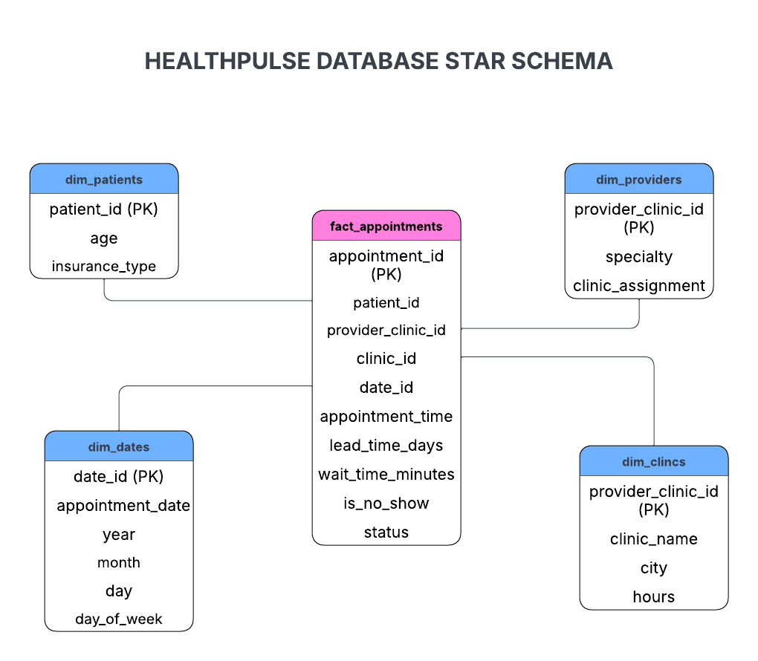
Figure 1. Star Schema Diagram

